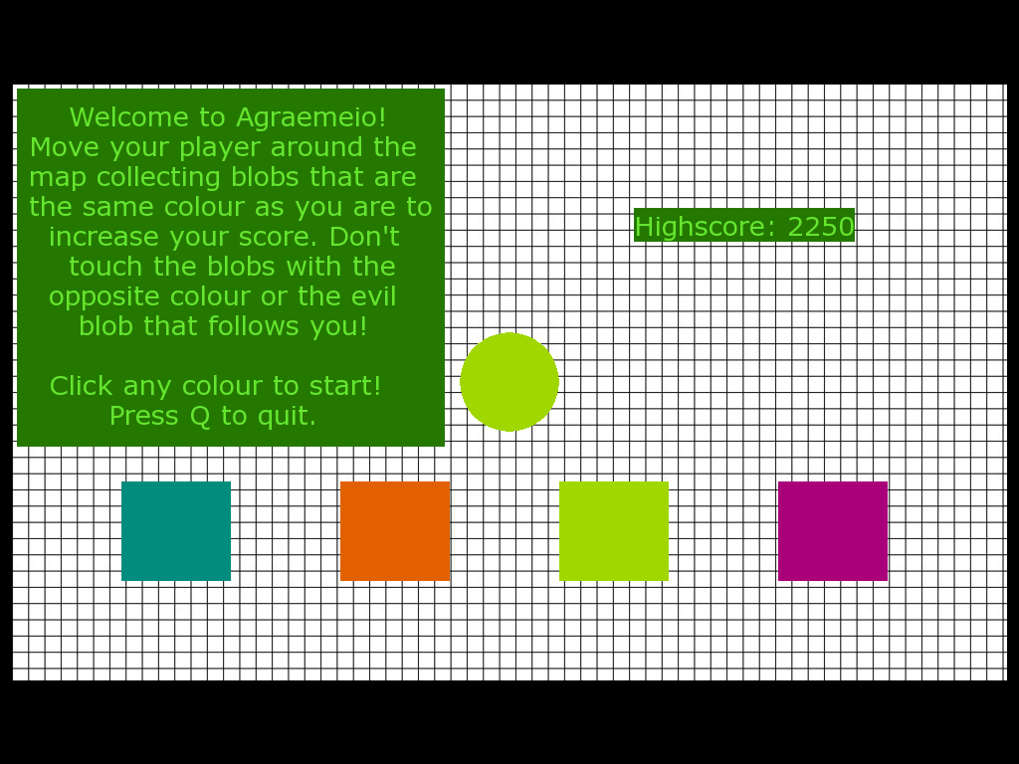Agraemeio User Guide

**Welcome to Agraemeio!**

Thank you for your purchase of this lovely game. I know you will not be disappointed! This game is fun for the whole family made for you by Graeme Woods.

**Main Menu:**

The game starts on the menu screen with for boxes across the bottom of the screen as show above. To start the game, select one of the boxes to choose your colour and start the game. The high score is also displayed on the main menu along with brief instructions.

**Playing the Game:**

Once a box is selected, the game loads with a countdown until the game starts. To move around the screen you must move your mouse and your player will follow. You must move around the map collecting blobs that are the same colour as your player. The more of these blobs that you collect the higher your score will get. The map is a finite area and there are boundaries along the edges. You must avoid the oppositely coloured blobs and watch out for the AI player that follows you. If you touch either of the above the game will end. The AI player will slowly accelerate and chase you faster and faster. Be careful and have fun!

**Retry Screen:**

When you die in the game, from either touching an oppositely coloured blob or the AI player, you arrive at the retry screen. You can either quit the game from there by pressing Q or retry by pressing space bar. The retry loads up the game again starting with the countdown screen then the game begins again.